Thin Layer Chromatography (TLC)
TLC is a simple, quick, and inexpensive procedure that gives the chemist a quick answer as to how many components are in a mixture. TLC is also used to support the identity of a compound in a mixture when the R_{f} of a compound is compared with the R_{f} of a known compound (preferably both run on the same TLC plate).
A TLC plate is a sheet of glass, metal, or plastic which is coated with a thin layer of a solid adsorbent (usually silica or alumina). A small amount of the mixture to be analyzed is spotted near the bottom of this plate. The TLC plate is then placed in a shallow pool of a solvent in a developing chamber so that only the very bottom of the plate is in the liquid. This liquid, or the eluent, is the mobile phase, and it slowly rises up the TLC plate by capillary action.
As the solvent moves past the spot that was applied, an equilibrium is established for each component of the mixture between the molecules of that component which are adsorbed on the solid and the molecules which are in solution. In principle, the components will differ in solubility and in the strength of their adsorption to the adsorbent and some components will be carried farther up the plate than others. When the solvent has reached the top of the plate, the plate is removed from the developing chamber, dried, and the separated components of the mixture are visualized. If the compounds are colored, visualization is straightforward. Usually the compounds are not colored, so a UV lamp is used to visualize the plates. (The plate itself contains a fluorescent dye which glows everywhere except where an organic compound is on the plate.)
How To Run a TLC Plate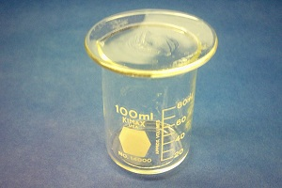 | Step 1: Prepare the developing container  The developing container for TLC can be a specially designed chamber, a jar with a lid, or a beaker with a watch glass on the top (the latter is used in the undergrad labs at CU). Pour solvent into the chamber to a depth of just less than 0.5 cm. To aid in the saturation of the TLC chamber with solvent vapors, you can line part of the inside of the beaker with filter paper. Cover the beaker with a watch glass, swirl it gently, and allow it to stand while you prepare your TLC plate.
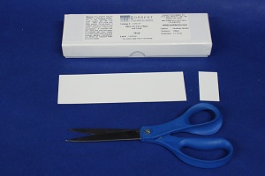 | Step 2: Prepare the TLC plate  TLC plates used in the organic chem teaching labs are purchased as 5 cm x 20 cm sheets. Each large sheet is cut horizontally into plates which are 5 cm tall by various widths; the more samples you plan to run on a plate, the wider it needs to be. Shown in the photo to the left is a box of TLC plates, a large un-cut TLC sheet, and a small TLC plate which has been cut to a convenient size. Handle the plates carefully so that you do not disturb the coating of adsorbent or get them dirty.
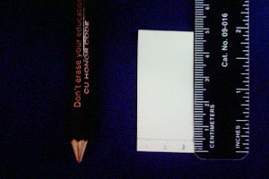 | Measure 0.5 cm from the bottom of the plate. Using a pencil, draw a line across the plate at the 0.5 cm mark. This is the origin: the line on which you will spot the plate. Take care not to press so hard with the pencil that you disturb the adsorbent. Under the line, mark lightly the name of the samples you will spot on the plate, or mark numbers for time points. Leave enough space between the samples so that they do not run together; about 4 samples on a 5 cm wide plate is advised.
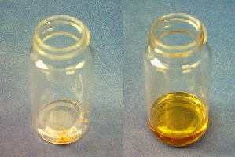 | Step 3: Spot the TLC plate  If the sample is not already in solution, dissolve about 1 mg in 1 mL of a volatile solvent such as hexanes, ethyl acetate, or methylene chloride. As a rule of thumb, a concentration of 1% usually works well for TLC analysis. If the sample is too concentrated, it will run as a smear or streak (see troubleshooting section below); if it is not concentrated enough, you will see nothing on the plate. Sometimes you will need to use trial and error to get well-sized, easy to read spots.
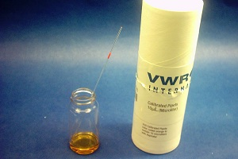 | Obtain a microcapillary we use 10µL microcaps - they are easier to handle than the smaller ones used in research labs. Dip the microcap into the solution and then gently touch the end of it onto the proper location on the TLC plate. Don't allow the spot to become too large - if necessary, you can touch it to the plate, lift it off and blow on the spot. If you repeat these steps, the wet area on the plate will stay small.
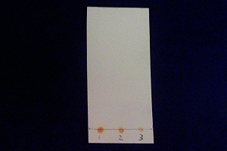 | This example plate has been spotted with three different quantities of the same solution and is ready to develop. If you are unsure of how much sample to spot, you can always spot multiple quantities and see which looks best.
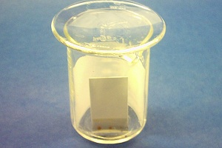 | Step 4: Develop the plate  Place the prepared TLC plate in the developing beaker, cover the beaker with the watch glass, and leave it undisturbed on your bench top. The solvent will rise up the TLC plate by capillary action. Make sure the solvent does not cover the spot.
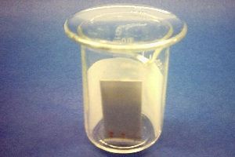 | Allow the plate to develop until the solvent is about half a centimeter below the top of the plate. Remove the plate from the beaker and immediately mark the solvent front with a pencil. Allow the plate to dry.
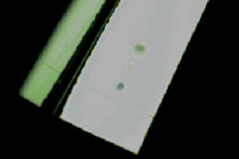 | Step 5: Visualize the spots  If there are any colored spots, circle them lightly with a pencil. Most samples are not colored and need to be visualized with a UV lamp. Hold a UV lamp over the plate and circle any spots you see. Beware! UV light is damaging both to your eyes and to your skin! Make sure you are wearing your goggles and do not look directly into the lamp. Protect your skin by wearing gloves.
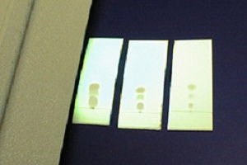 | If the TLC plate runs samples which are too concentrated, the spots will be streaked and/or run together. If this happens, you will have to start over with a more dilute sample to spot and run on a TLC plate.
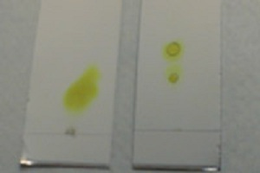 | Here's what overloaded plates look like compared to well-spotted plates. The plate on the left has a large yellow smear; this smear contains the same two compounds which are nicely resolved on the plate next to it.

TLC Solvents Choice
When you need to determine the best solvent or mixture of solvents (a "solvent system") to develop a TLC plate or chromatography column loaded with an unknown mixture, vary the polarity of the solvent in several trial runs: a process of trial and error. Carefully observe and record the results of the chromatography in each solvent system. You will find that as you increase the polarity of the solvent system, all the components of the mixture move faster (and vice versa with lowering the polarity). The ideal solvent system is simply the system that gives the best separation.
TLC elution patterns usually carry over to column chromatography elution patterns. Since TLC is a much faster procedure than column chromatography, TLC is often used to determine the best solvent system for column chromatography. For instance, in determining the solvent system for a flash chromatography procedure, the ideal system is the one that moves the desired component of the mixture to a TLC R_{f} of 0.25-0.35 and will separate this component from its nearest neighbor by difference in TLC R_{f} values of at least 0.20. Therefore a mixture is analyzed by TLC to determine the ideal solvent(s) for a flash chromatography procedure.
Beginners often do not know where to start: What solvents should they pull off the shelf to use to elute a TLC plate? Because of toxicity, cost, and flammability concerns, the common solvents are hexanes (or petroleum ethers/ligroin) and ethyl acetate (an ester). Diethyl ether can be used, but it is very flammable and volatile. Alcohols (methanol, ethanol) can be used. Acetic acid (a carboxylic acid) can be used, usually as a small percentage component of the system, since it is corrosive, non-volatile, very polar, and has irritating vapors. Acetone (a ketone) can be used. Methylene chloride or and chloroform (halogenated hydrocarbons) are good solvents, but are toxic and should be avoided whenever possible. If two solvents are equal in performance and toxicity, the more volatile solvent is preferred in chromatography because it will be easier to remove from the desired compound after isolation from a column chromatography procedure.
Ask the lab instructor what solvents are available and advisable. Then, mix a non-polar solvent (hexanes, a mixture of 6-carbon alkanes) with a polar solvent (ethyl acetate or acetone) in varying percent combinations to make solvent systems of greater and lesser polarity. The charts below should help you in your solvent selection. You can also download this pdf chart of elution order.

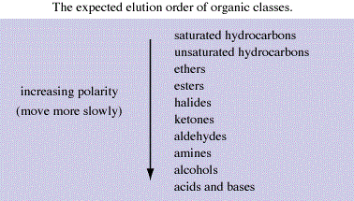

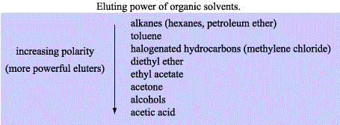

Interactions between the Compound and the Adsorbent
The strength with which an organic compound binds to an adsorbent depends on the strength of the following types of interactions: ion-dipole, dipole-dipole, hydrogen bonding, dipole induced dipole, and vander Waals forces. With silica gel, the dominant interactive forces between the adsorbent and the materials to be separated are of the dipole-dipole type. Highly polar molecules interact fairly strongly with the polar Si OH groups at the surface of these adsorbents, and will tend to stick or adsorb onto the fine particles of the adsorbent while weakly polar molecules are held less tightly. Weakly polar molecules generally tend to move through the adsorbent more rapidly than the polar species. Roughly, the compounds follow the elution order given above.

The R_{f} value
The retention factor, or R_{f}, is defined as the distance traveled by the compound divided by the distance traveled by the solvent.
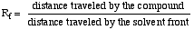
For example, if a compound travels 2.1 cm and the solvent front travels 2.8 cm, the R_{f} is 0.75:
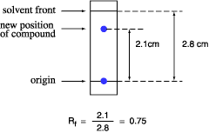
The R_{f} for a compound is a constant from one experiment to the next only if the chromatography conditions below are also constant:
- solvent system
- adsorbent
- thickness of the adsorbent
- amount of material spotted
- temperature
Since these factors are difficult to keep constant from experiment to experiment, relative R_{f} values are generally considered. "Relative R_{f}" means that the values are reported relative to a standard, or it means that you compare the R_{f} values of compounds run on the same plate at the same time.
The larger an R_{f} of a compound, the larger the distance it travels on the TLC plate. When comparing two different compounds run under identical chromatography conditions, the compound with the larger R_{f} is less polar because it interacts less strongly with the polar adsorbent on the TLC plate. Conversely, if you know the structures of the compounds in a mixture, you can predict that a compound of low polarity will have a larger R_{f} value than a polar compound run on the same plate.
The R_{f} can provide corroborative evidence as to the identity of a compound. If the identity of a compound is suspected but not yet proven, an authentic sample of the compound, or standard, is spotted and run on a TLC plate side by side (or on top of each other) with the compound in question. If two substances have the same R_{f} value, they are likely (but not necessarily) the same compound. If they have different R_{f} values, they are definitely different compounds. Note that this identity check must be performed on a single plate, because it is difficult to duplicate all the factors which influence R_{f} exactly from experiment to experiment.

Troubleshooting TLC
All of the above (including the procedure page) might sound like TLC is quite an easy procedure. But what about the first time you run a TLC, and see spots everywhere and blurred, streaked spots? As with any technique, with practice you get better. Examples of common problems encountered in TLC:
- The compound runs as a streak rather than a spot: The sample was overloaded. Run the TLC again after diluting your sample. Or, your sample might just contain many components, creating many spots which run together and appear as a streak. Perhaps, the experiment did not go as well as expected.
- The sample runs as a smear or a upward crescent: Compounds which possess strongly acidic or basic groups (amines or carboxylic acids) sometimes show up on a TLC plate with this behavior. Add a few drops of ammonium hydroxide (amines) or acetic acid (carboxylic acids) to the eluting solvent to obtain clearer plates.
- The sample runs as a downward crescent: Likely, the adsorbent was disturbed during the spotting, causing the crescent shape.
- The plate solvent front runs crookedly: Either the adsorbent has flaked off the sides of the plate or the sides of the plate are touching the sides of the container (or the paper used to saturate the container) as the plate develops. Crooked plates make it harder to measure R_{f} values accurately.
- Many random spots are seen on the plate: Make sure that you do not accidentally drop any organic compound on the plate. If get a TLC plate and leave it laying on your workbench as you do the experiment, you might drop or splash an organic compound on the plate.
- You see a blur of blue spots on the plate as it develops: Perhaps you used an ink pen instead of a pencil to mark the origin?
- No spots are seen on the plate: You might not have spotted enough compound, perhaps because the solution of the compound is too dilute. Try concentrating the solution, or spot it several times in one place, allowing the solvent to dry between applications. Some compounds do not show up under UV light; try another method of visualizing the plate (such as staining or exposing to iodine vapor). Or, perhaps you do not have any compound because your experiment did not go as well as planned. If the solvent level in the developing jar is deeper than the origin (spotting line) of the TLC plate, the solvent will dissolve the compounds into the solvent reservoir instead of allowing them to move up the plate by capillary action. Thus, you will not see spots after the plate is developed. These photos show how the yellow compound is running into the solvent when lifted from the developing jar.
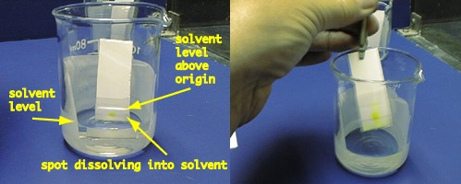

TLC Technique Quiz

